Answers to questions in

Lab 3: Image segmentation

Name: Markus Brislöv________________________________ Program: AUSY______________________

**Instructions**: Complete the lab according to the instructions in the notes and respond to the questions stated below. Keep the answers short and focus on what is essential. Illustrate with figures only when explicitly requested.

Good luck!

**Question 1**: How did you initialize the clustering process and why do you believe this was a good method of doing it?

Answers:

K-means is sensitive to initialisation of the clusters. Bad initialisation can result in convergence to local minima’s that yield a bad result. Therefore k-means++ was chosen to spread out the initial clusters, to avoid bad clustering, and to improve performance. It works by subsequently choosing the next cluster centre at random from the data, where each data point has a probability proportional to its squared distance to the previously closest cluster centre.

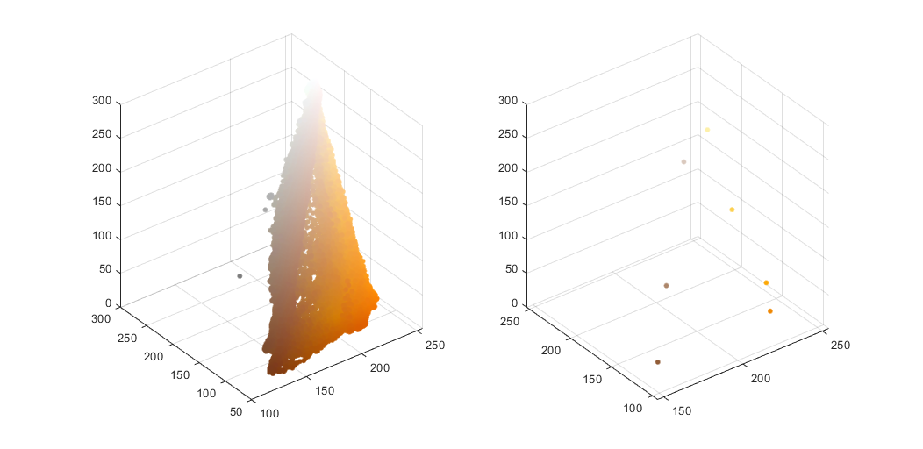

Figure 1.1: Data points on left and initial cluster centres on the right found by k-means++ for image ‘orange.jpg’

**Question 2**: How many iterations L do you typically need to reach convergence, that is the point where no additional iterations will affect the end results?

Answers:

Usually already after L = 3 the images look very similar to L = 20. But there are still some smaller segmentation differences, especially for the different shades of grey. Most of these differences disappear around L = 10. Though, when K is increased from 3 to 9 more iterations are required for these smaller segmentation differences, this time around L = 20. Adding blur or downscaling the image seemed to add more segmentation differences and therefore would require a few more iterations for convergence.

K = 3 for the following images:







K = 9 for the following images:







**Question 3**: What is the minimum value for K that you can use and still get no superpixel that covers parts from both halves of the orange? Illustrate with a figure.

Answers:

It depends to the parameters values but given K = 5 it took three iterations. When K is increased less iterations are required, e.g. K = 9 only took one.



**Question 4**: What needs to be changed in the parameters to get suitable super pixels for the tiger images as well?

Answers:

There is a lot of variation in the fur of tiger. Blur is useful to smooth out the differences to more easily generate super pixels. Additionally, a lower K value will segment more colours together. E.g.:



**Question 5**: How do the results change depending on the bandwidths? What settings did you prefer for the different images? Illustrate with an example image with the parameter that you think are suitable for that image.

Answers:

By increasing the spatial bandwidth, the size of the area in the spatial domain increases. That is, the width of the Gaussian kernel used here. This results in more pixels getting grouped together. A small spatial bandwidth creates many small sections (values below 3 produces weird results in our test images).



Parameter *color­_bandwidth* does the same as *spatial_bandwidth* but along the colour axis. Increasing this value yields in more colours getting grouped together. From the images below we can observe that there is barely a difference between values 12 and 20. That is due to *spatial­_bandwidth* becoming the limiting factor in grouping together pixels.



Best result:



**Question 6**: What kind of similarities and differences do you see between K-means and mean-shift segmentation?

Answers:

Similarities:

* Segments image into segments of varying colour (super pixels)
* Algorithms work iteratively, k-means converges to minima (minimise distances) while mean-shift converges to maxima (maximise density)

Differences:

* k-means doesn’t care about spatial information, similar coloured objects will be assigned to the same segmentation while not spatially connected.
* Number of clusters need to be defined for k-means, mean-shift finds the appropriate number of clusters given the input parameters.
* Size of clusters needs to be defined for mean-shift with *spatial_bandwidth* and *color_bandwidth*
* Mean-shift performed better at segmenting images of objects that consisted of similar colours
* Mean-shift performed better at generating super pixels in images where there was a lot of variation

**Question 7**: Does the ideal parameter setting vary depending on the images? If you look at the images, can you see a reason why the ideal settings might differ? Illustrate with an example image with the parameters you prefer for that image.

Answers:

Depending on the image content the ideal parameters will differ, some of these factors are:

* Size of objects, and details that should be included
* Variation or complexing in the content, e.g. the fur on the tigers or the trees in the background in ‘tiger2.jpg’
* Contrast between colours

|  |  |
| --- | --- |
| ‘orange.jpg’  colour_bandwidth = 18.0  radius = 8  ncuts_thresh = 0.06  min_area = 100  max_depth = 7  scale_factor = 0.4  image_sigma = 2.0 |  |
| ‘tiger1.jpg’  colour_bandwidth = 16.0  radius = 7  ncuts_thresh = 0.040  min_area = 105  max_depth = 10  scale_factor = 0.4  image_sigma = 2.1 |  |
| ‘tiger2.jpg’  colour_bandwidth = 8.0  radius = 4  ncuts_thresh = 0.04  min_area = 100  max_depth = 8  scale_factor = 0.4  image_sigma = 2.0 |  |

**Question 8**: Which parameter(s) was most effective for reducing the subdivision and still result in a satisfactory segmentation?

Answers:

*Max_depth­* determined the max number of subdivisions that could occur. Otherwise, *ncuts_thresh* wasuseful for decreasing the number of subdivisions. A good strategy I found was to make *max_depth* a bit to large and lower *ncuts_thresh* to remove the unnecessary subdivisions, usually a value between 0.04 to 0.07 was suitable. Another alternative was increasing the *radius*.

**Question 9**: Why does Normalized Cut prefer cuts of approximately equal size? Does this happen in practice?

Answers:

It’s because of the terms *assoc(A, V)* and *assoc(B, V)*. Where *assoc(A, V)* calculates the sum of all edges connected to any vertex *A*. When both segments are of equal size these values will be equal and *Ncut(A, B)* will become smaller.

If segment B is larger than A than the terms will differ where *assoc(A, V)* will have less associated edges and become a smaller value than *assoc(B, V).* This will cause it

$$\frac{cut(A,B)}{assoc(B,V)}$$

to be larger and Ncut will therefore become larger as well.

**Question 10**: Did you manage to increase *radius* and how did it affect the results?

Answers:

Increasing the *radius* will create larger segments and increase computational time. There will be a loss in detail, but the contours of larger objects will improve.

 

|  |  |
| --- | --- |
| Figure 10.1: radius = 3 | Figure 10.2: radius = 8 |

**Question 11**: Does the ideal choice of *alpha* and *sigma* vary a lot between different images? Illustrate with an example image with the parameters you prefer.

Answers:

Increasing alpha increases the potential cost an edge might have; Similar edges will therefore have a larger penalty if cut.

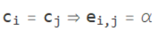

A smaller sigma places a larger emphasis on the differences between two pixels. So, two different pixels will have a smaller penalty if cut.

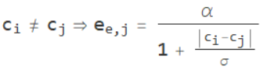





**Question 12**: How much can you lower K until the results get considerably worse?

Answers:

|  |  |  |
| --- | --- | --- |
| **Image** | **K** | **Comment** |
| ‘tiger1.jpg’ | 3 | Lower K values will include the stone block |
| ‘tiger2.jpg’ | 2 | The contour of the tiger gets a lot worse with a lower K |
| ‘tiger3.jpg’ | 2 | Lower K value included parts of the fence, but, the contour of tiger did get better |

**Question 13**: Unlike the earlier method Graph Cut segmentation relies on some input from a user for defining a rectangle. Is the benefit you get of this worth the effort? Motivate!

Answers:

Energy-based segmentation produces the best results out of the four methods we have tried. But it requires input for the location of the rectangle which can be a hurdle. For instance, if segmentations need to be done for a large number of images it might be preferable to opt for another segmentation algorithm.

 

|  |  |
| --- | --- |
| Figure 13.1: K-means | Figure 13.2: Mean-shift |

 

|  |  |
| --- | --- |
| Figure 13.3: Normalised Cut | Figure 13.4: Energy-based segmentation |

**Question 14**: What are the key differences and similarities between the segmentation methods (K-means, Mean-shift, Normalized Cut and energy-based segmentation with Graph Cuts) in this lab? Think carefully!!

Answers:

Similarities:

* All utilise segmentation
* All converge either to a maxima or minima to generate the segmentation(s)
  + Maxima: Mean-shift
  + Minima: K-means, Normalized Cut and Energy-based segmentation
* Both Mean-shift and Energy-based seg. use Gaussian

Differences:

* Energy-based seg. uses probabilities for classification unlike the others
* Energy-based seg. only has one foreground and background where there are multiple for Normalised Cut due to it being applied recursively.
* Energy-based seg. is the only method which requires information about the give image, the area for the mask
* K-means is the only method which doesn’t take spatial information into account